Assessment 3

SUBMITTED BY: Group 2
Aloled David Biju (s8160238)
Joshua Wiliam Emor (s8210677)
Iyo Hanakawa (s8153925)

SUBMITTED TO:
Lecturer: Dr. Hao Wu
Tutor: Dr. Hao Wu

SUBJECT:
(BCO6008) Predictive Analytics - SY
Table of Contents
1. Executive Summary
2. Introduction
3. Part 1: Scholarly Literature Study
Article 1: Social Media Activity Forecasting with Exogenous and Endogenous Signals (2022)
Article 2: Can customer engagement in social media be used as a predictor of operating revenue in SMEs? (2024)
Article 3: Hashtag recommendation for enhancing the popularity of social media posts (2023)
Article 4: Experimental Evaluation of Baselines for Forecasting Social Media Timeseries (2023)
Article 5: Dynamic Hashtag Recommendation in Social Media With Trend Shift Detection and Adaptation
3.1 Article Summaries
3.2 Comparative Analysis of Theories
4. Part 2: Practical Analytics Projects
4.1 Project Overview
4.1.1 Instagram Time Series Analysis (ARIMA/SARIMA)
4.1.2 Facebook Time Series Analysis (PROPHET)
4.1.3 YouTube Time Series Analysis (GRU)
4.2 Data Processing
4.3 Methodology Comparison
4.4 Model Implementation and Evaluation
5. Conclusion
6. Part 3: Individual Reflection Report
6.1 Aloled David Biju (s8160238)
6.2 Joshua Wiliam Emor (s8210677)
6.3 Iyo Hanakawa (s8153925)
7. References

1. Executive Summary
This report presents an examination of Time Series Analysis in Social Media Trend Analysis through both academic research and predictive forecasting projects. Five peer-reviewed journals were studied to understand the methods being used currently for forecasting levels of social media activity, customer engagement, and content visibility. The literature provided evidence that although the use of traditional models such as ARIMA may still provide acceptable forecasting when dealing with stable patterns of social media activity, forecasting accuracy can often be enhanced through the incorporation of additional external information sources into the forecasting process, and/or the utilisation of adaptive machine learning techniques.
In order to supplement the findings identified in the above literature review, three forecasting projects were completed. In the first project, an ARIMA and SARIMA model(s) were developed and tested to analyze Instagram "reach" forecasts. The second project utilized Prophet to evaluate publishing activity as well as seasonal patterns on Facebook. Lastly, the third project implemented a GRU Deep Learning Model to capture the complex and highly dynamic engagement behavior on YouTube.
The results of each of these three projects indicate that the optimal forecasting technique(s) for each social media platform differ significantly. Overall, this study demonstrates that there is no one size fits all solution when selecting a forecasting model. Rather, a model should be selected based on the type of platform being analyzed, the type of data available, and the goals of the forecasting application.
2. Introduction
Social media produces a significant amount of temporal data (time dependent) that allows organizations to forecast how users will engage with social media content, as well as the success of future business efforts. This report will use a literature review of five peer-reviewed articles on the application of Time Series Analysis in Trend Analysis for Social Media Data as well as a comparison of three practical forecasting projects (using ARIMA/SARIMA, Prophet and GRU Models) to analyse which social media platform is best suited to each model.
3. Part 1: Scholarly Literature Study
Article 1: Social Media Activity Forecasting with Exogenous and Endogenous Signals (2022)
Incorporating both social media data and factors from other data types like news, Reddit discussions and real-time conflict events, the researchers were able to develop an enhanced model for predicting social media usage. They pointed out a weakness with current social media usage forecasting methods, those that depend on historical social media activity can't account for quick shifts in usage due to a newsworthy event. Therefore, they developed a Topic Activity Predictor (TAP), which imply LSTM models along with dynamic signal selection to produce better forecasts. Combining endogenous and exogenous variables improved forecast accuracy and showed that each topic has its own set of best performing external predictors. Overall, their work shows how important it is to incorporate news and other outside influences when developing predictive models for social media usage and provides a method for making time series predictions more adaptable.
Article 2: Can customer engagement in social media be used as a predictor of operating revenue in SMEs? (2024)
This study aims to explore the relationship between social media customer engagement (CE) and operating revenues (OR) for businesses. The author identified a gap in research that, while companies use social media interactions, there is no research to define whether social media interactions are predictive of business performance in terms of revenue. A sample of 100 small and medium sized companies (SME) was used for eight years to measure the relationship between CE and operating revenue using ARIMA time series modeling.
Two methods of management were tested in the study:
1.perception of external and inefficient management. Perception of unprofessional and internal management.
2. External professional staff that are experts in marketing and the coordination of social media and e-commerce.
Poor statistical fit (R^2 values of -0.34 to +.45) and non-significant statistical significance (p > .05) were found for companies with unprofessional internal managers, suggesting that CE does not predict revenue.
When professionally-managed companies (using a digital strategist) based on the use of coordinated social media campaigns and e-commerce strategies are analyzed, however, the statistical fits are slightly higher, ranging from (R^2 = .72 to .81) and statistically significant (p < .001), suggesting that the operating revenue is better predicted by professional management of social media CE. The findings of this analysis indicate that the indicators of CE through social media are useful in making forecasts of revenue only if they are professionally managed and professionally conducted with supporting data literacy.
Article 3: Hashtag recommendation for enhancing the popularity of social media posts (2023)
In the course of this research the researchers explored various ways to make use of existing content with a new systematic approach to enrich and heighten users' motivation for interacting with such content. With no strategy around the creation of post content, it has made the ability for end-users to see that content subject to rapid changes in the respective platform. They were forced to build a hashtag recommender system which involved graph-based platform of all trending hashtags and graph-based platform of user favourite hashtags to map the word used in posts.
Their research findings show how automated and contextually relevant hashtags used on the post have overcome the limits of distribution, leading to huge growth in engagement figures (likes, shares, comments etc.) within the post, and in real-world exposure, measured using proven and reliable metrics. The framework presented in this study, which involves matching content that forms the metadata of the posting to previously trending content, proved that an individual's online identity is an outcome of planning and can be enhanced in terms of digital identity as a whole.
Article 4: Experimental Evaluation of Baselines for Forecasting Social Media Timeseries (2023)
The researchers in this study examined how effective traditional forecasting techniques were at predicting time series social media forecasts. They stated that most studies suggest advanced modeling strategies for time series forecasting without providing an adequate comparison to baseline forecasting models, which makes it difficult to understand what additional value may be gained by introducing new forecasting models. Therefore, they tested ARIMA, Hawkes Process, Shifting Baseline, and Ensemble forecasting models across different Twitter and YouTube datasets and across various international contexts. Several forecasting evaluation metrics, such as RMSE and sMAP), were used to evaluate each model's forecast accuracy. Their results demonstrated that there is no one model that performs better than all other models, however, their analysis suggested that ARIMA performed best when attempting to predict total volume/overall social media activity, while the Hawkes Process performed much better when identifying specific temporal relationships within the data. The researchers contributed a significant benchmark for future studies related to social media time series forecasting, and provided evidence of the need for researchers to identify appropriate forecasting methodologies based upon the type of data being analysed and the purpose of their predictive modeling, versus simply choosing a single methodology.
Article 5: Dynamic Hashtag Recommendation in Social Media With Trend Shift Detection and Adaptation
This paper introduces H-ADAPTS. It is a system that adapts to trends and automatically suggests relevant hashtags for its social media posts. The problem is that static models don’t change to accommodate new hashtags or when existing hashtags change in meaning. H-ADAPTS addresses this by monitoring post streams in real-time using Apache Storm and recognizing when trending hashtags differ significantly from known trends using a custom ranked Jaccard distance metric. When a significant change is detected, the model efficiently retrained on a small window of recent posts using transfer learning and progressive fine-tuning.
The paper tested the system on two Twitter datasets, one about COVID-19 and another about the 2020 US election. Across both cases, the system performed better than the usual static models, especially when the trends suddenly changed. Instead of continuous updates, it uses selective, event-driven retraining to maintain a high recommendation accuracy at low computational costs.

3.1 Article Summaries
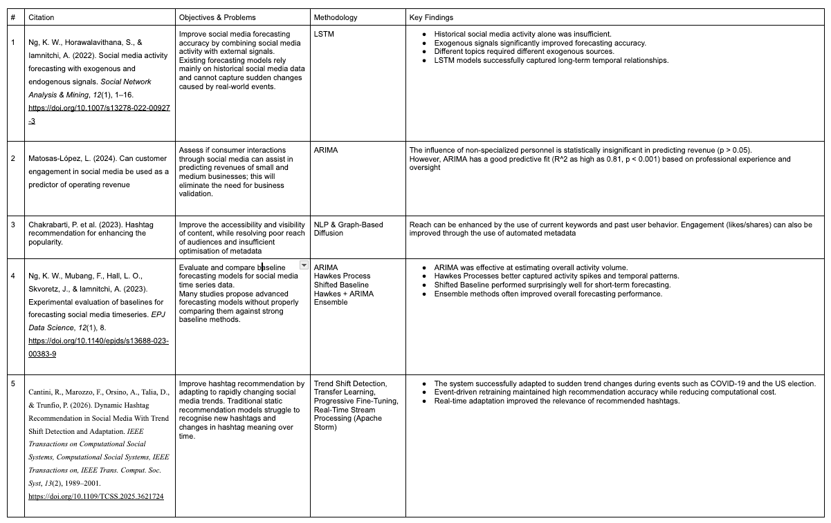

3.2 Comparative Analysis of Theories
Articles 2 and 4 clearly demonstrate how well traditional time-series models (such as ARIMA) continue to be appropriate in the context of predicting both business activity and social media activity. However, as Article 1 demonstrates, when you incorporate an array of external data sources (e.g., news articles, discussion forums), along with your social media data, you are able to improve forecast accuracy. Additionally, Articles 3 and 5 focus upon a specific type of system, the hashtag recommendation system and each demonstrates that developing a set of highly relevant, and adaptable, hashtags will dramatically enhance both engagement levels and the amount of exposure associated with the related content. Overall, while these studies indicate that there is no one-size-fits-all approach to utilizing social media analytic tools to forecast or optimize engagement, they also provide insight into what factors influence the effectiveness of an approach the purpose of the forecasting effort; the characteristics of the data being analyzed; and the extent to which it may need to be adapted to evolving social media trends. Therefore, future research efforts should seek to develop new approaches by integrating established methods for forecasting (using techniques such as ARIMA), deep learning algorithms capable of processing large amounts of real-time data; and real-time external information.
4. Part 2: Practical Analytics Projects
4.1 Project Overview
4.1.1 Instagram Time Series Analysis (ARIMA/SARIMA)
This project was chosen because it fits well within the category of Social Media Trend Analysis, as it used time-series forecasting methods on Instagram reach data. The dataset contained 365 days of Instagram reach data. This enabled analysis of user engagement with the content during a 1-year time frame.
During the Data Preparation phase, the date column (date) was transformed into datetime format and then used as the time series index. No major issues with missing values or duplication existed in this step

Figure 1. Instagram Reach Over Time
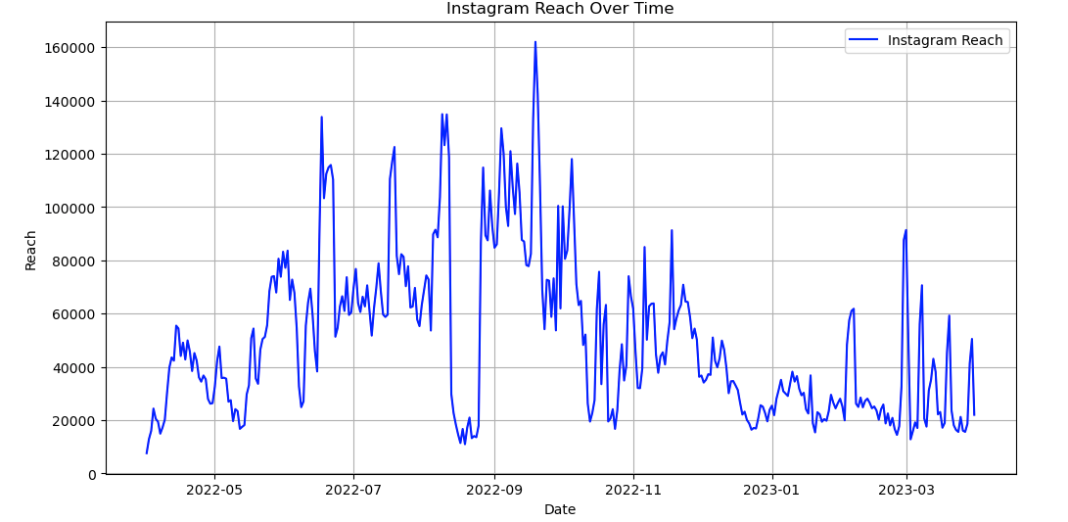
In viewing the Time Series Plot of Instagram reach over the course of the year, large swings in Instagram reach are seen, reaching high points in mid-2022 before decreasing to lower amounts through early 2023, indicating some type of Trend and Seasonal behavior in the data.
To further investigate these patterns, seasonal decomposition was performed using an additive model with a 30-day seasonal period.

Figure 2. Seasonal Decomposition of Instagram Reach
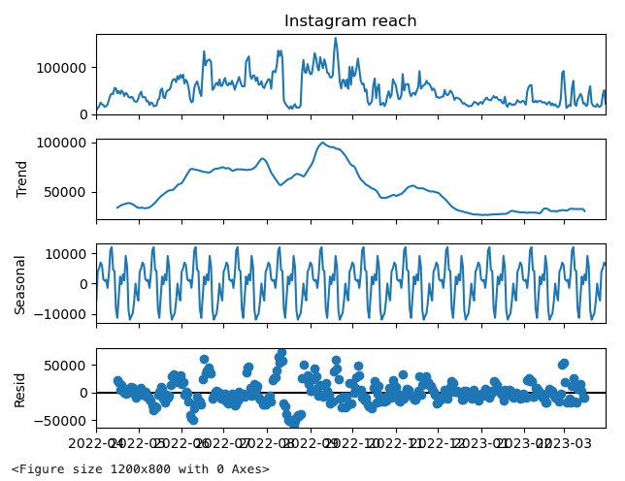
A clear trend line and consistent patterns are shown in the trend and seasonal components respectively. As can be determined from the above finding both ARIMA and SARIMA will be valid choices of forecasting method.
Using the ACF/PACF Plots to help determine the proper parameters for the forecasting models.
Figure 3. ACF and PACF Analysis
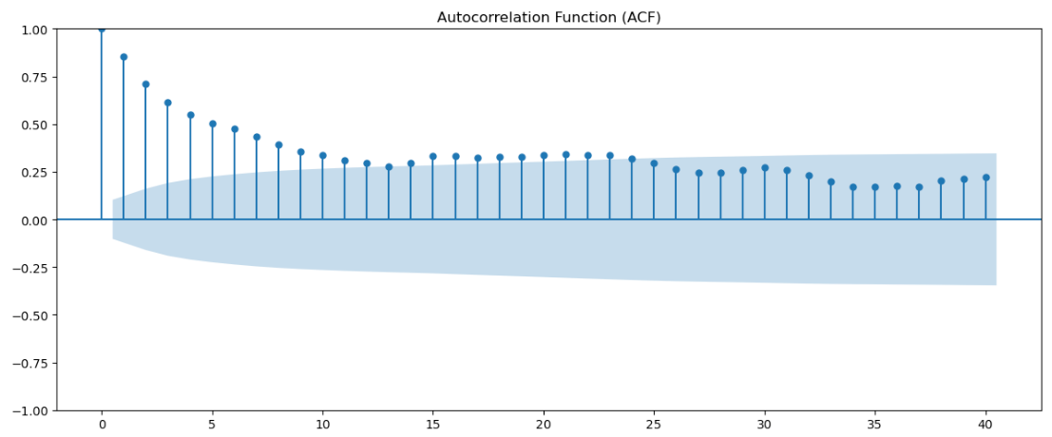

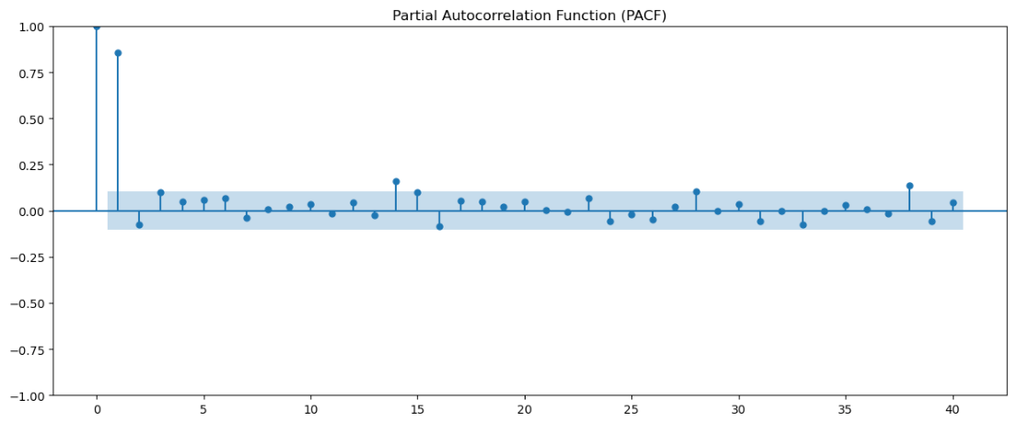

The ACF plot has demonstrated significant autocorrelation at multiple lags while showing very little at other lags. The PACF plot has demonstrated significant autocorrelation at lag 1 and none thereafter. From the ACF/PACF plots, it proves that the past values of Instagram reach influence current value(s). Therefore, we have enough information to apply autoregressive based forecasting models.
Several candidate models were compared, including AR(1), AR(2), MA(1), ARMA(1,1), ARIMA(1,1,1), and SARIMA(1,1,1)(1,1,1,30).

- Figure 4. Model Comparison Using AIC, BIC, and Forecast Error Metrics
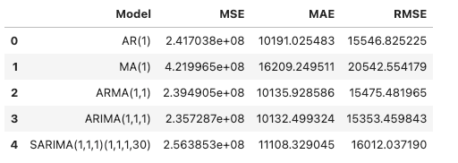
SARIMA achieved the lowest AIC (7491.97) and BIC (7511.03), indicating the best statistical fit. However, ARIMA(1,1,1) produced the lowest forecasting errors, achieving the smallest MSE, MAE, and RMSE values. This demonstrates that the model with the best fit does not always provide the most accurate predictions.
A 30-day forecast was generated using the ARIMA(1,1,1) model.
Figure 5. 30-Day Forecast of Instagram Reach Using ARIMA (1,1,1)
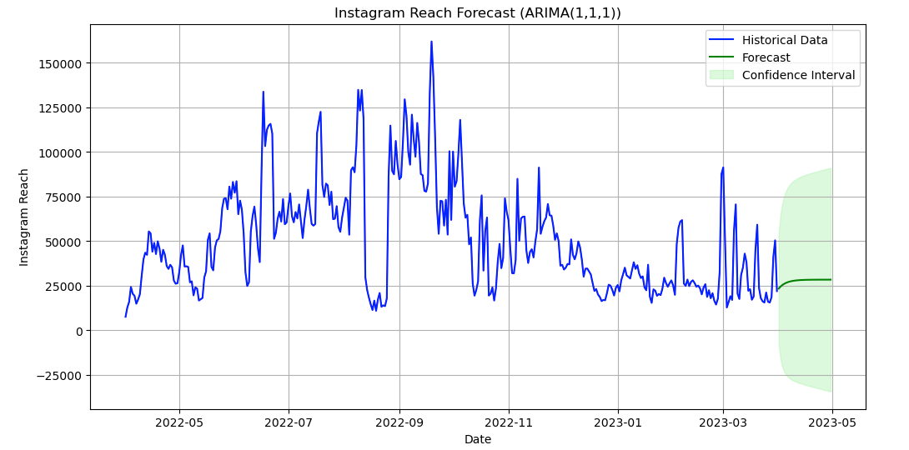
This forecast indicates that Instagram reach is likely to remain at approximately 25,000 – 30,000 for the next thirty days. Although the confidence intervals for the forecast are quite broad this can be attributed to the volatile nature of social media engagement data.
Limitations of this project include not performing an ADF test to formally check if the data is stationary prior to developing our models. Also, our original dataset included only Instagram reach and not other external influences like hashtags, post frequencies, or advertising campaigns. Improvements for future projects could be to include those additional external influences into your dataset and comparing them against additional advanced methods of forecasting like Prophet or GRU models.
The project overall provided a real-world example of the time-series forecasting process from preparing data to decomposing data to analyzing auto-correlations to evaluating model performance to creating forecasts. It demonstrated the importance of considering both a model’s goodness-of-fit statistics and forecast accuracy when choosing a forecasting method.

4.1.2 Facebook Time Series Analysis (PROPHET)
A time series analysis is also available for Facebook Prophet.Facebook Prophet also offers a time series analysis (Univariate Curve Fitting) option.
The selected project is modeling and estimation of publishing volume using the open source Facebook Prophet library, which is suitable, as the overall goal is to predict what activity people are doing on social media in this group or organization. Data includes all posts published on the Medium platform between January 2015 and June 2017; each individual post includes a timestamp that has daily post-production data throughout 2+ years. The data was prepared by cleaning the timestamps and separating the target variables into a separate dataframe with y (goal metric) and ds (datestamp) columns that are required to use Prophet API.
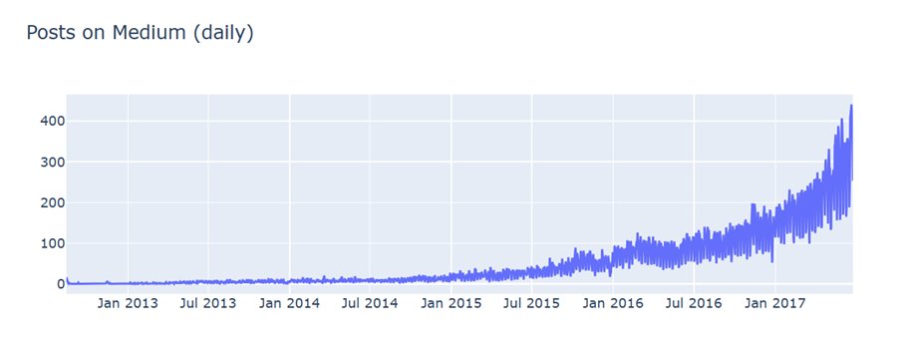

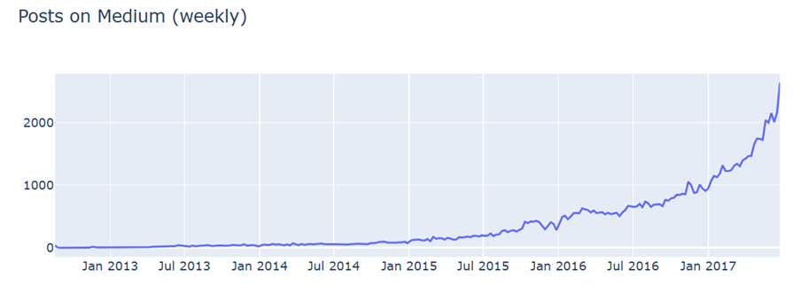

But the raw daily time series data referred to time, revealed much higher frequency noise. Downsampling subjected the daily data to heavy aggregation to weekly time periods, so as to provide a visualisation of the actual properties of the data. This allowed for the discovery of an ongoing upward trend, as well as a number of abrupt downward trend points as a result of the annual holiday season being present in the data at each of the downsampling period.

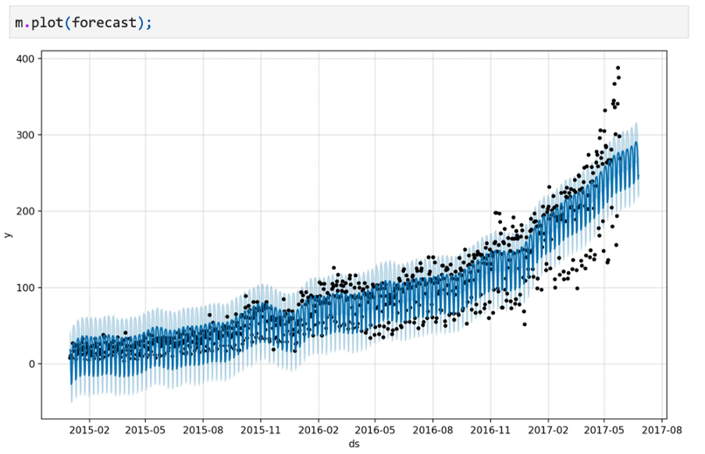

The baseline additive Prophet model was trained on the raw scene dataset; this model also had major structural issues due to extremely high levels of heteroscedasticity (H1). Heteroscedasticity will occur as the weekly peak and trough dataset will have increased distances between the peaks and troughs as the platform's total volume has expanded non-linearly over time. The baseline additive Prophet model was able to predict an accurate data set as the model forced a constant seasonal amplitude in a quest to predict future points of data, resulting in a misalignment between actual data and the data predicted by the baseline additive Prophet model in the standard-error confidence intervals for the model's output.
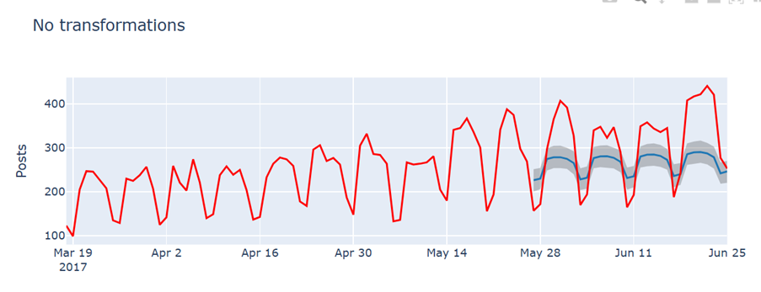

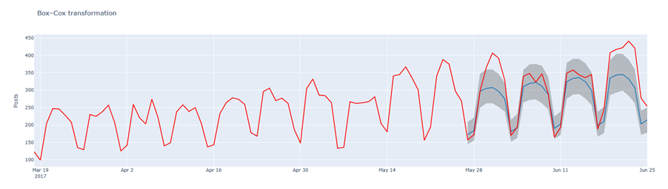
The Box-Cox transformation (scipy.stats.boxcox) was performed to remove the effect of the changing variance over time prior to training. This mathematical transformation made the variance of the historical data more stable, and an optimized forecast was computed, which could be dynamically adjusted to the higher variance of the historical data when the inverse transformation was calculated. Overall, MAPE was lowered to 11.7% with actual points remaining stable at the end of the time period.
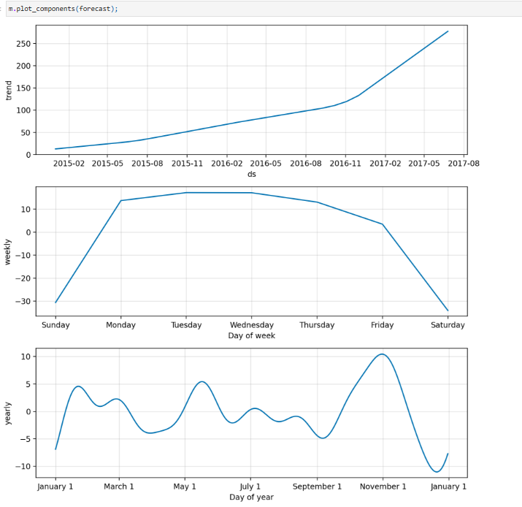
Prophets structural decomposition techniques (model.plot_components) were used to create 3 separate layers. These layers were:

1. The trend is a piecewise linear model which was only constructed from real internal company factors, to illustrate that the nature of the trend for the professional writing business was one of sharp and accelerating growth from late 2016 onwards.
2. The weekly seasonality was measured with a stepwise bar chart showing that most posting was Monday through Friday and weekend (Saturday/Sunday) activity for a professional writing business was in a low level or trough (deep below the average level on the weekdays).
3. The year over year data was used to plot year over year patterns and a Fourier series was fit to the data to establish a yearly seasonality, which revealed that the structural trough, the minimum period of the business, happens at Christmas (December 25), a snapshot of the professional writing business where it temporarily ceases.

An advantage of Prophet over traditional ARIMA approaches (See Section 4.1.2) is that Prophet does not require complex mathematical differencing because it handles non-stationary data, irregular intervals and structural breaks naturally, but a disadvantage is that Prophet cannot provide a causation related explanation as it models the fluctuation of business activity as mathematical curves, and does not model an impact related to external operational factors. The next step(s) would be to add variables upstream using Article 3's guidance as a number of regressors: e.g. add optimization rates for hashtags or frequency of posting
4.1.3 YouTube Time Series Analysis (GRU)
YouTube is a chaotic system primarily driven by viewers. The amount of watches, likes, comments etc. depends on YouTube's algorithm, if the channel goes viral, current events happening in the world etc. In this portion of the project, we will attempt to predict YouTube trends (daily watch count, comment volume, etc.) as a function of time as a continuous time series. One thing to note about YouTube trends is that they are extremely non-linear. It is not uncommon for a video to gain 10x its views in one day, then start decaying the next. We will need a model that learns the long term upward trend of the data but can also account for these bursts. This section lays the foundation for utilizing neural networks to learn these patterns.
4.2 Data Processing
A number of data preprocessing pipelines were implemented in order to prepare the YouTube time-series dataset for model training and evaluation.
- Data Cleaning and Aggregation: Transformed the YouTube interaction logs into a daily time-series dataset, enabling us to observe user activity combined over each 24-hour period. If there were missing values resulting from API downtime or platform delays, the available number was used to keep everything in order.
- Feature Engineering (Exogenous Alignment): Using the idea from the foundational methodology of Paper 1 (TAP Framework), the dataset structure accounts for the fact that internal platform history (endogenous data) alone is not enough to figure out spikes in engagement. Therefore, time-series markers were added to the data to show when people were interested in things.
- Stationarity and Transformation: While statistical models require differencing to make sure the data have no trends, the deep learning pipeline retained the raw data. This way the computer can look at the numbers and figure out what they mean.
- Normalization: MinMax Scaler, which scales all values in a range of [0,1], was used to normalize the data. While the algorithm attempts to learn from the data, this normalization phase helps to maintain clarity.
- Temporal Windowing (Train/Test Split): In order to prevent any leakage, the data was split strictly by time factor. We turned the history into sliding lookback windows (using the past n days to predict the next day) and then split everything into an 80% training set and a 20% test set.
4.3 Methodology Comparison
The benchmarking gaps found in the ARIMA model are addressed by this configuration. Long-term baseline volume can be estimated using conventional methods like the shifted baseline or linear models like ARIMA, but they are unable to capture abrupt, event-driven peaks. On the other hand, Gru models demonstrate how deep learning models get beyond these restrictions. LSTMs can handle intricate social media patterns, but at a significant computational cost, as the ARIMA model shows. The YouTube analysis uses a GRU to streamline the pipeline, which demonstrates that GRUs use significantly fewer parameters than an LSTM while still being able to quickly respond to abrupt trend shifts.
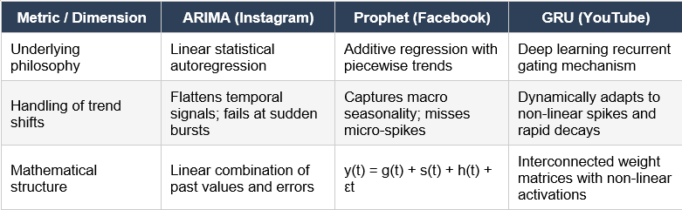
Multi-Platform Strategic Implications
The cross-examination of these three workflows reveals that model selection must be based on the structure of the target platform (different models for different platforms):
- Instagram (ARIMA): The ARIMA model proves highly effective for a platform like Instagram, where its activity is usually steady with slow but predictable changes.
- Facebook (Prophet): PROPHET is the most suitable model for Facebook due to its engagement with business. Its clear weekly patterns, holiday season, and marketing cycles are also in line with SME.
- YouTube (GRU): YouTube is a special case compared to Instagram and Facebook. Since it's a platform that is extremely unpredictable, the only method that could fit into it is GRU. YouTube video recommendations are based on recommendation algorithms instead of a fixed method; this makes engagement usually come in sudden spikes. The GRU can react swiftly to sudden spikes in activity while maintaining stability on long-term trends thanks to its ability to gradually modify its internal state.
Ultimately, after comparing every model used in those three platforms, it is clear that no single forecasting model is globally superior. Instead, optimal predictive analytics relies on matching platform instability with the corresponding model. The traditional model is suitable for stable platforms, while algorithm-guided or fast-moving platforms need models that can handle the sudden changes/spikes.

4.4 Model Implementation and Evaluation
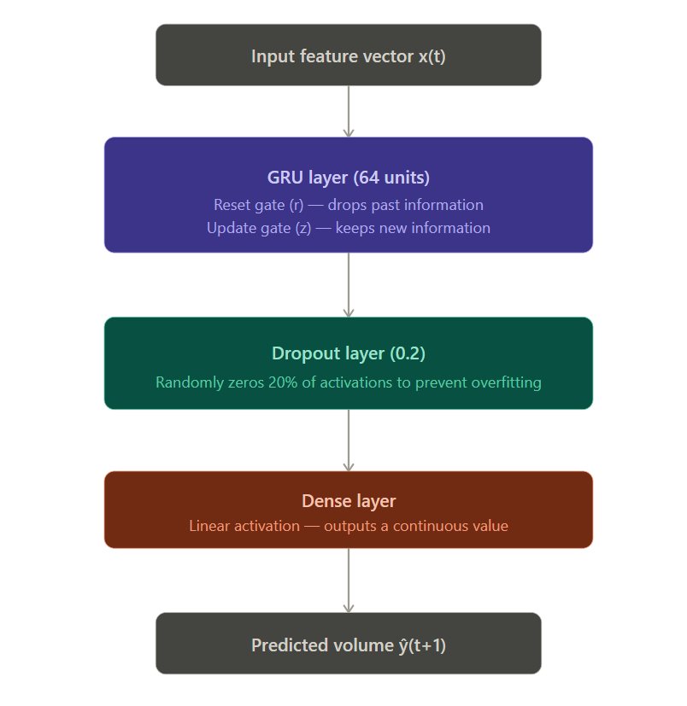
- Architecture Specifications: The network is made up of a GRU layer that has 64 hidden units. This GRU layer uses a reset gate to decide how much of the past context to forget and an update gate to decide what new information to pass on. The network also has a dropout layer with a rate of 0.2 to stop it from overfitting. Additionally, it has a dense output layer that is set up for single-step regression.
- Loss Optimization: The network was trained using the Mean Squared Error (MSE) loss function and the Adam optimizer. This allows the network to change its learning rate as it goes.
- Evaluation Framework: We followed the rules set by Arima to test the model. We looked at how it did on the test data using some standard metrics: mean absolute error (MSE), root mean squared error (RMSE), and mean absolute percentage error (MAPE).
The evaluation metrics test the GRU architecture to see whether it is good at handling the ups and downs of YouTube time-series data while checking if it maintains its mistakes low when things are steady and also does well when there are spikes in traffic on YouTube. The GRU network had to be good at adapting to these changes to show that it is an architecture for this kind of data.
5. Conclusion
A number of previous studies have explored the application of time-series analysis to identify and analyse trends through social media, from both theoretical and practical perspectives. From the literature review it was clear that there are a number of ways in which forecasts could be improved upon, by incorporating external sources of data into their forecasting processes, by selecting adaptable forecasting methods and by optimizing levels of engagement. Furthermore, from the literature review it also became apparent that different types of social media forecasting data require different forms of forecasting techniques.
The three Practical Projects provided our hands-on experience working with three distinct forecasting techniques which are ARIMA/SARIMA, Prophet and GRU. The Instagram Project found that traditional statistical models continued to be applicable to predict engagement at relatively stable engagement-based platforms. The Facebook Project found that due to its ability to incorporate trend and seasonal patterns in its modeling process, Prophet was better suited to predict business-related social media content. The YouTube project demonstrated how deep-learning models like GRU can predict non-linear behavior and sharp spikes in engagement.
When comparing all three projects, they support the findings of the literature review. There was no single forecasting technique that was capable of beating all other forecasting techniques. Rather, forecasting performance was dependent on the characteristics of the platform(s), as well as the nature of the underlying data. Future research could look at combining traditional statistical models, deep learning techniques and real-time external signals to develop more accurate, and adaptable social media forecasting systems.

6. Part 3: Individual Reflection Report
6.1 Aloled David Biju (s8160238)
In this predictive analytics project, real-life experiences were combined with academia.
An expert handling the time series analytics is beneficial, as Article 2 noted, to ensure that it is accurate. When it came to seeing the actual application of time series analytics, however, I realized the technical basis for the advertised "benefit" was needed: To detect structural data issues (e.g. heteroscedasticity) and apply transformations (e.g. Box-Cox) requires professional data skills. Without these modifications, models will make wrong predictions (e.g. a range of predictions for the future, e.g. +/- 10%) and companies may make wrong decisions about how to invest resources due to wrong future predictions.
Analysis of Script for Analytical & Code Analysis
The analysis of the Prophet Library setup on schedule has demonstrated great algorithmic performance. Forecasting with Prophet models instead of autoregressive lags via curve fitting algorithm: additivity.
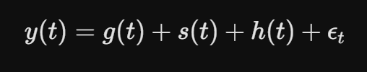
The model for trend analysis is a piecewise linear model with an automatically determined changepoint; the short-term fluctuations are represented by binary indicators; and the annual seasonal behaviour is represented by a partial Fourier series:
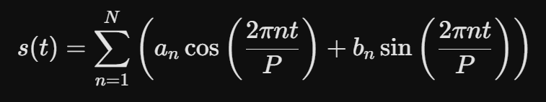

The differences in mathematics produce clear and logical layers which directly correspond to the various processes that are repeated in humans' everyday experience (e.g., the decrease in post volume on weekends and on days that are known as observed holidays by the general public).
Future Research
I'm going to take the structural frameworks of our literature review and add the technical approaches that we took with our hands-on project to expand this conclusion. The next generation of models should add the criteria for optimizing metadata provided in Article 3 as an exogenous regressor and not only rely on historical data on volume to forecast the time series of volume. Data teams can create one analytic pipeline that models upstream process trigger and Downstream Platform Development without compromising the efficiency of the process by adding variables to the Prophet initialization directly with m.add_regressor()
6.2 Joshua Wiliam Emor (s8210677)
This project improved my understanding of time series analysis. At first, forecasting seemed like a one-size-fits-all method, but the literature review showed that is not the case. Article 1 emphasized that having platform history alone isn’t sufficient; we also need outside signals to explain sudden changes. I witnessed this in action across the three projects. ARIMA worked well with Instagram's relatively stable, slow-moving data. Prophet captured Facebook's business-driven weekly and seasonal patterns. The GRU model I used for YouTube was necessary because the platform's engagement is influenced by recommendation algorithms and viral spikes, making it far less linear than the other two. Working through the GRU's data preprocessing, especially by keeping the data raw and non-stationary instead of differencing it as ARIMA required, helped me see why deep learning is its own category and not just a "more advanced" statistical model.
Personally, the most useful part was tying the three projects together for the conclusion. This made clear the main point of the report: there is no one technique that is universally better, only techniques that are appropriate to particular data structures. The model with the best AIC or BIC score does not always provide the most useful forecast. For future work, I would like to test adding exogenous regressors, like trending topic indicators, across all three models to see if the platform-specific advantages identified here hold true when we consistently introduce external information.
6.3 Iyo Hanakawa (s8153925)
This project provided a deeper understanding on how to utilise time-series analysis for predicting trends from social media. The Literature Review allowed me to learn that forecasting will improve when utilising additional outside information as well as when choosing a model based on the properties of the data. This project also gave me hands-on experience in Data Preparation, Seasonal Decomposition, ACF/PACF Analysis, Model Evaluation and Forecasting. I utilized Python libraries including Pandas, Matplotlib and Statsmodels to apply the above-mentioned steps as well as to evaluate the performance of different forecasting methods through AIC, BIC, RMSE, MAE and MSE. Additionally, one important thing I found is that although you may have a statistically better performing model it doesn't necessarily mean it produces the most accurate forecast. For my next project I'd like to look into adding an external variable (such as hashtag or marketing event) and compare the performance of forecasting models with traditional models vs. Deep Learning Models (LSTM & GRU).
7. References
abdullahhunjra (2025). GitHub - abdullahhunjra/YouTube-Engagement-Forecasting-using-Deep-Learning-and-Time-Series-Models-FastAPI-Docker: YouTube Engagement Forecasting with GRU, LSTM, Prophet, and SARIMA. Forecasting likes, views, and comments using deep learning and statistical time series models. [online] GitHub. Available at: https://github.com/abdullahhunjra/YouTube-Engagement-Forecasting-using-Deep-Learning-and-Time-Series-Models-FastAPI-Docker [Accessed 3 Jun. 2026].
Cantini, R., Marozzo, F., Orsino, A., Talia, D., & Trunfio, P. (2026). Dynamic Hashtag Recommendation in Social Media With Trend Shift Detection and Adaptation. IEEE Transactions on Computational Social Systems, Computational Social Systems, IEEE Transactions on, IEEE Trans. Comput. Soc. Syst, 13(2), 1989–2001. https://doi.org/10.1109/TCSS.2025.3621724
Chakrabarti, P., Malvi, E., Bansal, S., & Kumar, N. (2023). Hashtag recommendation for enhancing the popularity of social media posts. Social Network Analysis and Mining, 13(1), 21. https://doi.org/10.1007/s13278-023-01024-9
kashnitsky (2020). Topic 9. Part 2. Time series with Facebook Prophet. [online] Kaggle.com. Available at: https://www.kaggle.com/code/kashnitsky/topic-9-part-2-time-series-with-facebook-prophet [Accessed 3 Jun. 2026].
Matosas-López, L. (2024). Can customer engagement in social media be used as a predictor of operating revenue in SMEs? Journal of Open Innovation, 10(4), N.PAG. https://doi.org/10.1016/j.joitmc.2024.100380
Ng, K. W., Horawalavithana, S., & Iamnitchi, A. (2022). Social media activity forecasting with exogenous and endogenous signals. Social Network Analysis & Mining, 12(1), 1–16. https://doi.org/10.1007/s13278-022-00927-3
Ng, K. W., Mubang, F., Hall, L. O., Skvoretz, J., & Iamnitchi, A. (2023). Experimental evaluation of baselines for forecasting social media timeseries. EPJ Data Science, 12(1), 8. https://doi.org/10.1140/epjds/s13688-023-00383-9
snehalkhandewale (2024). Instagram_Time Series. [online] Kaggle.com. Available at: https://www.kaggle.com/code/snehalkhandewale/instagram-time-series [Accessed 3 Jun. 2026].

